### 5V/2A SupplySoil Moisture Sensor Probe Specifications

|  |  |
| --- | --- |
| **VH400 Sensor** | |
| Power consumption | < 7mA |
| Supply Voltage | 3.3V to 20 VDC. |
| Dimensions | See drawing below. |
| Power on to Output stable | 400 ms |
| Output Impedance | 100K ohms |
| Operational Temperature | -40ºC to 85ºC |
| Accuracy | 2% |
| Output | 0 to 3V related to moisture content |
| Shell Color | Red |
| Voltage Output Curves | [Curves](http://www.vegetronix.com/Curves),  [Piecewise linear equations](http://www.vegetronix.com/Products/VH400/VH400-Piecewise-Curve.phtml) |

**Soil Moisture Sensor Probe Wiring Table**

|  |  |
| --- | --- |
| Bare | Ground |
| Red | POWER:  3.3V to 20 VDC. |
| Black | OUT: (0 to 3V related  to moisture content.) |

**VH400 Soil Moisture Sensor Probe Drawing**

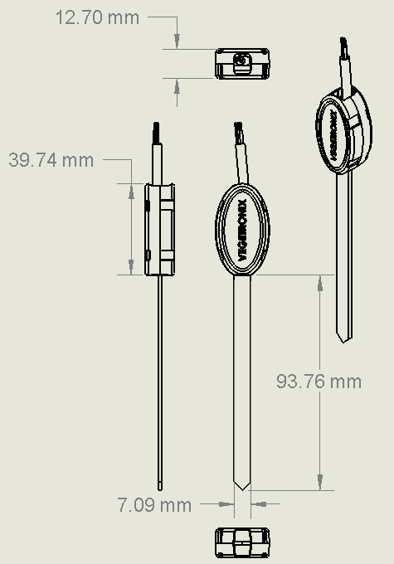

VH400 Soil Moisture sensor Drawing